Morecambe Bay Academy

Teacher of Science

Dear applicant,

Thank you for your interest in joining Morecambe Bay Academy. Morecambe Bay Academy is part of The Bay Learning Trust, a community of like-minded schools. We serve our community to enable pupils to flourish and achieve excellence. The Trust was established by Ripley St Thomas Church of England Academy in 2017. You can find out more about our Trust by visiting our website:The Bay Learning Trust

We are a large and friendly 11-18 secondary school at the heart of our local community. Our core values of Belong, Believe and Achieve are central to all that we do. We have high expectations and aspirations for all of our young people and they are incredibly receptive and are willing to learn and work hard.

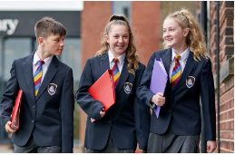

You will be a classroom practitioner with a record of excellent outcomes for pupils in your care. The ideal candidate will have a passion for supporting all learners in fulfilling their potential.

In return we can offer you excellent training and development opportunities across the Trust and a friendly and welcoming staff. If you would like to have an informal, confidential conversation about the role, please contact us on gmilce@morecambebayacademy.co.uk

Yours faithfully,

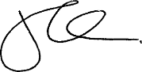

John Cowper
Executive Headteacher
Morecambe Bay Academy

